2 Minute Form
Trip Name: Westhaven Marina to Point Chevalier
Check-in Name and Phone:
Date: Branch:
Leaders
Cell Phone Number
VHF Call Sign &/or Vessel Name
Vehicle make, model, registration, colour
General Plan
Note: If plan changes, you must notify your Check-in person.
Latest Time Off the Water |  |  |  |  | TMP/ AMP used²⁰
Tide/ Forecast Lake Level | Low |  |  | High | Other
Communications Carried²¹
Communications | We will be communicating as a group on VHF Channel _____
Equipment Carried
Trip Report
(Use other side if more space required)

Activity | Westhaven to Pt Chevalier | Centre | Auckland | Location |  |  | Waitemata Harbour |  | Difficulty¹ |  |  | beginner
Activity Description | Meet Westhaven Marina meet outside Yachting New Zealand, 86 Westhaven Drive. Launch from the floating jetty. Paddle under the Harbour Bridge and along to Point Chevalier. Return. |  |  |  | Leader qualification req.² |  | Trip leader
Get in Location | Westhaven Marina |  |  |  | Chart/ Map no.⁴ |  | 532 |  | Distance |  |  | 15km
Get out Location | Westhaven Marina |  |  |  | Coastguard Channel |  | 80 |  | Nowcasting |  |  | 21
Emergency get out ⁵ | Anywhere you can land |  |  |  | Emergency / Coastguard Station |  | Auckland |  | Phone |  |  | *500  09 303 4303
 |  |  |  |  | Drinking Water⁶ | No |  | Toilets⁷ |  |  | At Pt Chevalier
Emergency Response | Refer Emergency Response Booklet |  |  |  |  |  |  | Parking⁸ |  |  | Maybe
Specific Equipment Required⁹ | Hi-viz clothing and flags – high traffic area. |  |  |  | Working Communications equipment in this area¹⁰ | Cell phone  Sat phone |  |  |  | Mountain Radio |  |  | PLB  VHF
Other resources  and notes¹¹ |  |  |  |  | Weather Parameters¹² | Beginner: no significant surf or swell, wind under 15 knots.  Intermediate: surf or ocean swells less than 1.5 metres or wind under 25 knots.  Advanced: any condition that’s suitable for the trip’s aims.
Previous incidents¹³

Safety Management¹⁴
Hazard |  | Significant? |  | Management Strategy¹⁵ |  |  |  | Hazard | Significant? | Management Strategy¹⁵
Cold Water |  | Yes |  | Carry spare dry clothes and shelter |  |  |  | Deep Water | Yes | Correctly fit PFDs
Medical Conditions |  | Yes |  | - Leader has first aid qualification  - Ask customers about medical conditions |  |  |  | Bad Weather | Yes | Understand weather forecasts.  Have back up plans or pull out if necessary
Capsizing |  | Yes |  | - Correctly fit PFDs  - Skills at performing rescues. |  |  |  | Heat / Sun | Yes | - Protective Clothing (worn)  - Sun Screen  - Plenty of drinks  - Sunglasses
Panic |  | Yes |  | Ensure conditions match level  of skills |  |  |  | Obstacles | Ye s | Awareness of reefs, navigational hazards, nets
Parking |  | no |  | Parking restrictions have changed recently so take care where you park. On a recent trip several vehicles were towed for parking in a 3 hour spot - $200 fine- ouch. |  |  |  | Other Vessels | Yes | - Understand the “rules of the sea”  - “Be seen” – Have two of the following; flag, brightly coloured kayak, brightly coloured Pfd or hat. At night: an all round white light & a powerful torch.
Fishermen |  | No |  | There is a lot of fisherman along the wall just north of the bridge – go wide so you don’t get snagged - fishermen can get very cranky. |  |  |  | Rough water | Yes | Water can get surprisingly rough under the Harbour Bridge – ensure that those going are capable of handling the conditions.
Written up by: | Larraine Williams |  | Approved By: |  | Russell Williams | Signed: | RW |  | Date: | 12 Mar. 14 | Review in: | 12 months from date of approval

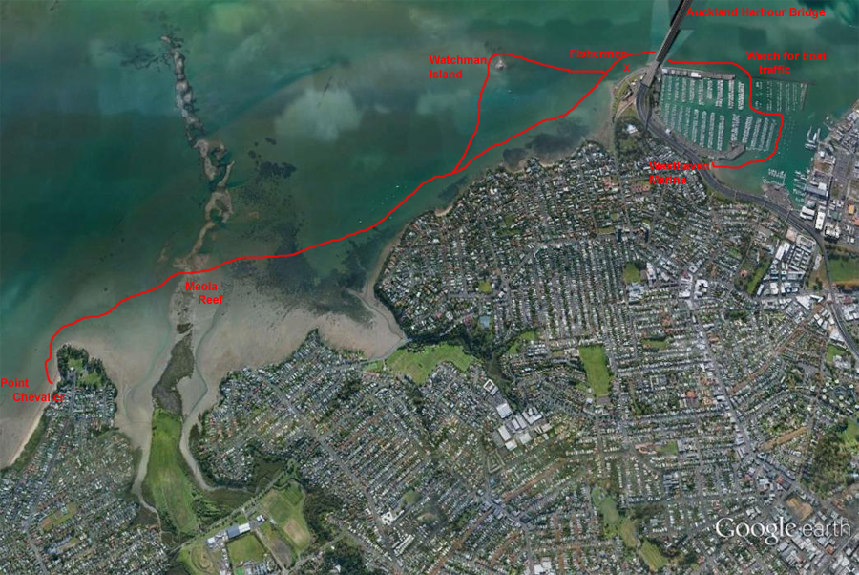
Additional Information Sheet (Optional)
Introduction (A general introduction)
Description (A description of the tour – as if you were selling the idea to someone)
Local Attractions |  | Transport/ Local Operators
 | Contact details |  | Contact details
Local Eateries
 | Contact details
Accommodation/ Campsite Locations |  |  | Facilities
Name |  |  | Cabins |  | Fuel
Phone |  |  | Showers |  | Power
E-mail |  |  | Toilets |  | Water Access
Website |  |  | Laundry |  | Pool
Physical Address |  |  | Water |  | Fires Allowed
Other |  |  | Supplies
Other information

